CHAPTER SIX

Decisions and Looping

You have so far explored some fundamental language concepts such as variables, data types, operators, expressions, and constants. However, all the scripts you have written have worked in a linear fashion: that is to say, the PHP engine starts at the first line of the script, and works its way down until it reaches the end. Typically, PHP does not always work in that fashion. Things get a lot more interesting when you start introducing decisions and loops.

A decision lets you run either one section of code or another, based on the results of a specific test. Meanwhile, a loop lets you run the same section of code over and over again until a specific
condition is met.

6.1 Making decisions

Like most programming languages, PHP lets you write code that can make decisions based on the result of an expression. Decisions will enable you take actions such as:

- If an administrative user is logged in, print a special menu.
- Print a different page header if it’s after three o’clock.
- Notify a user if new messages have been posted since she last logged in.

All of these actions have something in common: they make decisions about whether a certain logical condition involving data is true or false. When making decisions, the PHP engine boils down an expression into true or false. Those true and false values are used by language constructs such as if () to decide whether to run certain statements in a program. In essence, if you can create a test in the form of an expression that evaluates to either true or false, you can use that test to make decisions in your code.

PHP gives you a number of statements that you can use to make decisions:

- The if statement
- The else and elseif statements
- The switch statement

6.1.1 The if () statement

The basic form of an if () construct is as follows:

if ( expression ) {
// Run this code if expression (condition) is true
}
// More code here
If the expression inside the parentheses evaluates to true, the code between the braces is run. If the expression evaluates to false, the code between the braces is skipped. That’s really all there is to it. It ’ s worth pointing out that any code following the closing brace is always run, regardless of the result of the test. So in the preceding example, if expression evaluates to true, both the Run this code and More code here lines are executed; if expression evaluates to false, Run this code is skipped but More code here is still run.

Example

$widgets = 23;
if ( $widgets > = 10 & & $widgets < = 20 ) {
echo “We have between 10 and 20 widgets in stock.”;
}

The key point to remember is that, no matter how complex your test expression is, if the whole
expression evaluates to true the code inside the braces is run; otherwise the code inside the braces is skipped and execution continues with the first line of code after the closing brace.

You can have as many lines of code between the braces as you like, and the code can do anything, such as display something in the browser, call a function, or even exit the script. If you only have one line of code between the braces you can, in fact, omit the braces altogether.

6.1.2 The if () ….. else statement

You can enhance the if () construct by adding an else statement to it. This lets you run one block of code if an expression is true, and a different block of code if the expression is false.

The basic form of an if ….. else construct is as follows:

if (expression)
//code to be executed if condition is true;
else
//code to be executed if condition is false;

Example

<html><body>
<?php
$d=date("D");
if ($d=="Fri")
echo "Have a nice weekend!";
else
echo "Have a nice day!";
?>
</body></html>
Output: Have a nice day!

6.1.3 The elseif statement

If you want to execute some code if one of the several conditions is true, then use the elseif statement.

if (condition1)
// code to be executed if condition is true;
elseif (condition2)
// code to be executed if condition is true;
elseif (condition3)
// code to be executed if condition is true;
else
// code to be executed if condition is false;

Example

<html>
<body>
<?php
$d=date("D");
if ($d=="Fri")
echo "Have a nice weekend!";
elseif ($d=="Sun")
echo "Have a nice Sunday!";
else
echo "Have a nice day!";
?>
</body>
</html>
Output: Have a nice day (because we on Tuesday)

6.1.4 The Switch statement

Sometimes you want to test an expression against a range of different values, carrying out a different task depending on the value that is matched. The switch statement is used to avoid long blocks of if ….. elseif …... else code just in case you happen to be evaluating the same expression.

Syntax

switch (expression){
case label1:
code to be executed if expression = label1;
break;
case label2:
code to be executed if expression = label2;
break;
default:
code to be executed if expression is different from both label1 and label2;
}

Example

if ( $userAction == “open” ) {
// Open the file
} elseif ( $userAction == “save” ) {
// Save the file
} elseif ( $userAction == “close” ) {
// Close the file
} elseif ( $userAction == “logout” ) {
// Log the user out
} else {
print “Please choose an option”;
}

As you can see, this script compares the same variable, over and over again, with different values. This can get quite cumbersome, especially if you later want to change the expression used in all of the tests. PHP provides a more elegant way to run these types of tests: the switch statement. With this statement, you include the expression to test only once, then provide a range of values to test it against, with corresponding code blocks to run if the values match.

switch ( $userAction ) {
case “open”:
// Open the file
break;
case “save”:
// Save the file
break;
case “close”:
// Close the file
break;
case “logout”:
// Log the user out
break;
default:
print “Please choose an option”;
}
Here’s how it works. The first line features the switch statement, and includes the condition to test — in this case, the value of the $userAction variable — in parentheses. Then, a series of case statements test the expression against various values: ”open” , ” save” , and so on. If a value matches the expression, the code following the case line is executed. If no values match, the default statement is reached, and the line of code following it is executed.

Note that each case construct has a break statement at the end of it. Why are these break statements necessary? You insert a break statement at the end of each code block just to exit the entire switch construct, once the PHP engine has found a case value that matches the expression, ensuring that no more code blocks within the switch construct are run.

6.2 Looping

When a computer program does something repeatedly, it’s called looping. This happens a lot — for example, when you want to retrieve a set of rows from a database, print rows of an HTML table, or print elements in an HTML <select> menu.

The two looping constructs discussed in this section are:

- while loops
- do … while loops
- for loops

Their specifics differ, but each requires you to specify the two essential attributes of any loop: what code to execute repeatedly and when to stop. The code to execute is a code block just like what goes inside the curly braces after an if() construct. The condition for stopping the loop is a logical expression just like an if() construct’s test expression.

The basic idea of a loop is to run the same block of code again and again, until a certain condition is met. As with decisions, that condition must take the form of an expression. If the expression evaluates to true, the loop continues running. If the expression evaluates to false, the loop exits, and execution continues on the first line following the loop’s code block.

6.2.1 While loop

Syntax
while (condition)
{
// code to be executed;

}
// more code here

Here’s how it works. The expression (condition) inside the parentheses is tested; if it evaluates to true, the code block inside the braces is run. Then the expression is tested again; if it’s still true, the code block is run again, and so on. However, if at any point the expression is false, the loop exits and execution continues with the line after the closing brace.

Example

<html>
<body>
<?php
$i = 0;
$num = 50;
while( $i < 10)
{
$num--;
$i++;
}
echo ("Loop stopped at i = <b>$i</b> and num = <b>$num</b> " );
?>
</body>
</html>
Loop stopped at i = 10 and num = 40

Example

<?php
$widgetsLeft = 10;
while ( $widgetsLeft > 0 ) {
echo “Selling a widget... “;
$widgetsLeft - - ;
echo “done. There are $widgetsLeft widgets left. < br / > ”;
}
echo “We ’ re right out of widgets!”;
? >

First a variable, $widgetsLeft , is created to record the number of widgets in stock ( 10 ). Then the while loop works through the widgets, “selling ” them one at a time (represented by decrementing the $widgetsLeft counter) and displaying the number of widgets remaining. Once $widgetsLeft reaches 0, the expression inside the parentheses ( $widgetsLeft > 0 ) becomes false , and the loop exits. Control is then passed to the echo() statement outside the loop, and the message “ We ’ re right out of widgets! ” is displayed.

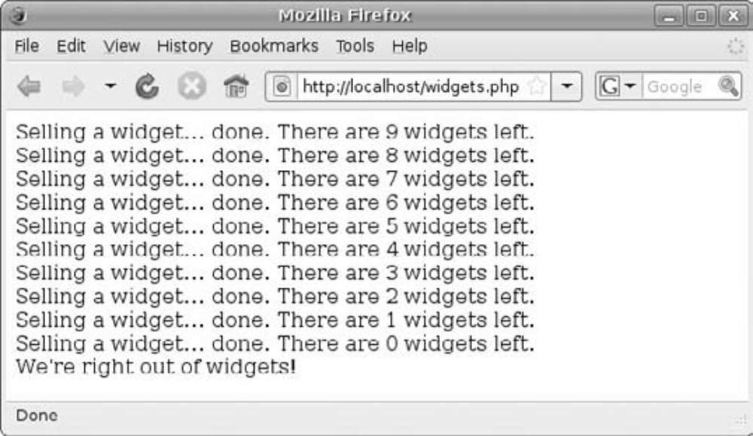

6.2.2 The do … while loop

Sometimes it’s useful to be able to run the code in the loop at least once before checking the expression, and this is exactly what do...while loops let you do. For example, if the expression you are testing relies on setting a variable inside the loop, you need to run that loop at least once before testing the expression.

do
{

// code to be executed;

} while (condition);

Example

<?php
$width = 1;
$length = 1;
do {
$width++;
$length++;
$area = $width * $length;
} while ($area < 1000);
echo “The smallest square over 1000 sq ft in area is $width ft x $length ft”;
?>

6.2.3 for loop

The for statement is a bit more complex than do and do...while , but it ’ s a neat and compact way to write certain types of loops. Typically, you use a for loop when you know how many times you want to repeat the loop. You use a counter variable within the for loop to keep track of how many times you have looped.

Syntax

for ( expression1; expression2; expression3 ) {
// Run this code
}
// More code here

As with while and do...while loops, if you only need one line of code in the body of the loop you can omit the braces.

You can see that, whereas do and do...while loops contain just one expression inside their parentheses, a for loop can contain three expressions. These expressions, in order, are:

- The initializer expression - This is run just once, when the for statement is first encountered. Typically, it ’ s used to initialize a counter variable (for example, $counter = 1 )
- The loop test expression - This fulfils the same purpose as the single expression in a do or do...while loop. If this expression evaluates to true, the loop continues; if it’s false, the loop exits. An example of a loop test expression would be $counter < = 10
- The counting expression - This expression is run after each iteration of the loop, and is usually used to change the counter variable — for example, $counter++

for ( $i = 1; $i < = 10; $i++ ) {
echo “I ’ ve counted to: $i < br / > ”;
}
echo “All done!”;

6.2.4 Break Statement

Normally, a while, do...while, or for loop will continue looping as long as its test expression evaluates to true. However, you can exit a loop at any point while the loop is executing by using the break statement.

Why would you want to do this? Well, in many situations it is useful to be able to break out of a loop. The infinite for loop is a good example; if you don’t break out of an infinite loop somehow, it will just keep running and running, consuming resources on the server. Another common reason to break out of a loop is that you want to exit the loop prematurely, because you have finished doing whatever processing you needed to do.

Example

$count = 0;
while ( true ) {
$count++;
echo “I ’ ve counted to: $count < br / > ”;
if ( $count == 10 ) break;
}

Example

$randomNumber = rand( 1, 1000 );
for ( $i=1; $i < = 1000; $i++ ) {
if ( $i == $randomNumber ) {
echo “Hooray! I guessed the random number. It was: $i < br / > ”;
break;
}
}

6.2.5 Continue statement

Continue lets you prematurely end the current iteration of a loop and move onto the next iteration. This can be useful if you want to skip the current item of data you ’ re working with; maybe you don ’ t want to change or use that particular data item, or maybe the data item can ’ t be used for some reason (for example, using it would cause an error).

Example

for ( $i=1; $i < = 10; $i++ ) {
if ( $i == 4 ) continue;
echo “I ’ ve counted to: $i < br / > ”;
}
echo “All done!”;

The above example counts from 1 to 10, but it misses out the number 4 (which is considered unlucky in many Asian cultures):

